Abstract Template for AMTA 2026 Symposium
Rogelio L. Rivert¹, MEMBER, AMTA, and Jeff Smith², FELLOW, AMTA

Antenna Measurements Center (AAMC), Florida, U.S.
- MACOM Systems, Tadam, Wisconsin, U.S.

ABSTRACT
This electronic document serves as a “live” template and outlines the most important considerations for your abstract within its style sheet. For AMTA 2026, it is crucial that both the abstract and the final paper undergo a peer review process to ensure high quality. A minimum of three reviewers will be assigned to evaluate your abstract and paper. Quality is essential, and we encourage you to take this review process seriously to enhance the overall standard of your work. An IEEE abstract is a concise summary of a research paper, typically ranging from 250 to 350 words. The abstract should clearly state the main objective of your research, highlighting the problem you are addressing. Briefly describe the methodology or approach used in your study, followed by a summary of the key findings or results obtained. Finally, highlight the significance of your findings and their implications in the field. Use clear and concise language without jargon. By following these guidelines, and template provided your abstract will effectively communicate the core aspects of your research. You are welcome to add a figure; a combination of text and figures provides a better result to understand the proposed work. You can include the most relevant citations or references in the abstract. Authors should indicate their membership status with AMTA, specifying whether they are a member, student member, senior member, or fellow. CRITICAL: Do not use symbols, special characters, or Math in the title or abstract of the paper.

Index Terms—antenna, calibration, robotic, UAS. (Index terms are mandatory; arranged in alphabetical order.)
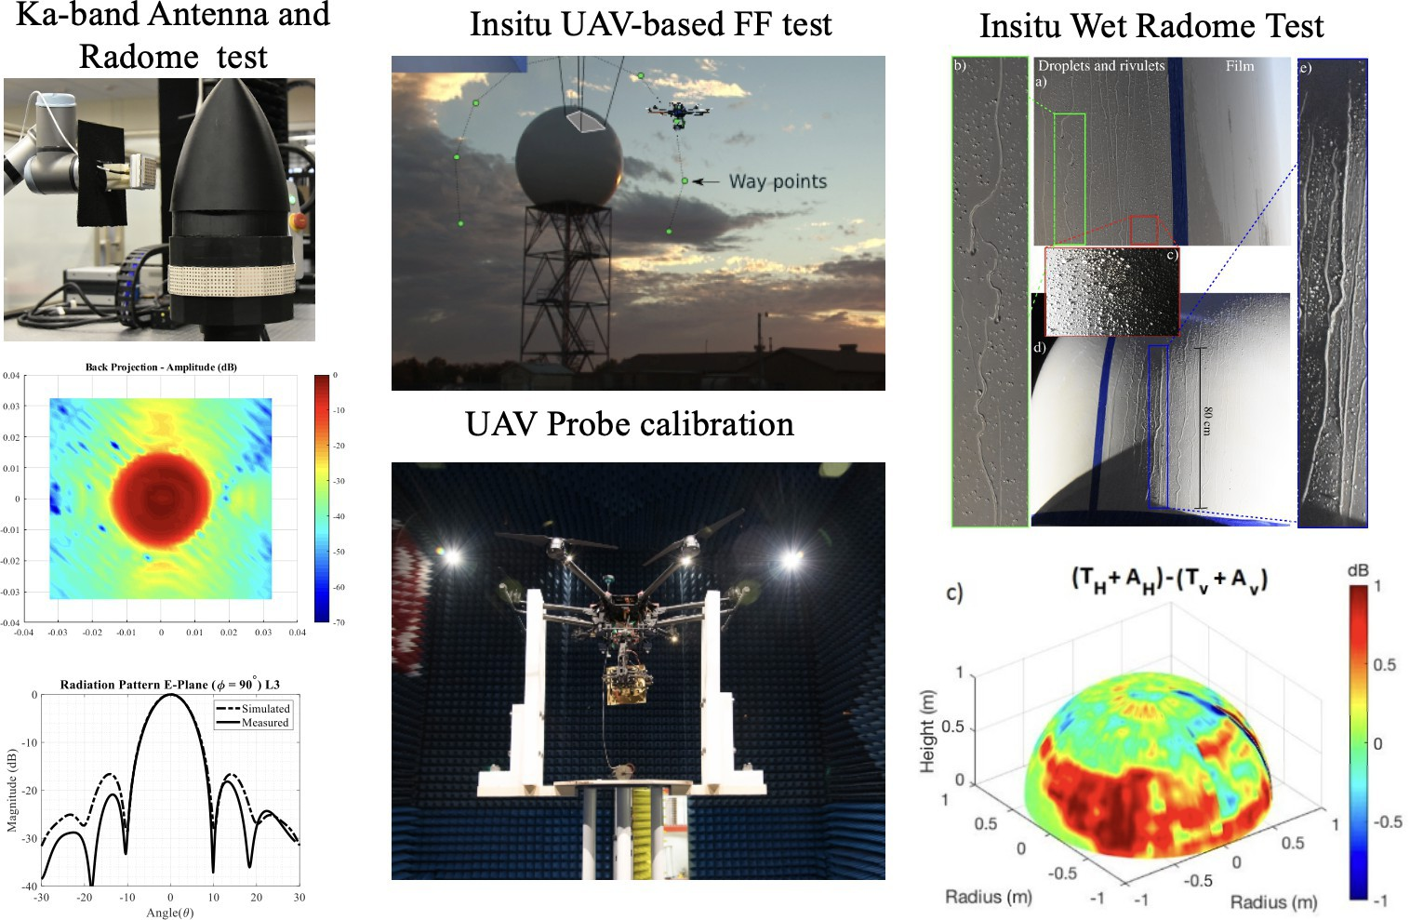

Figure 1: Figures and references are optional for AMTA abstracts, if it is used, the caption should be concise description should be provided to clearly explain what the figure represents, including any relevant details that help the reader understand the context. References should follow IEEE format [1].

References

[1] J. L. Salazar et al., “Advancements in Measurement and Calibration of Multifunction Phased Array Radars: Exploring Future Research Directions,” In Proceedings of the European Conference on Antennas and Propagation (EuCAP) 2025, pp. 12-16. Stockholm, Sweden, between March 30 and April 4, 2025., doi: 10.1109/PAST43306.2019.9021042.

